**Web Designing**

**MODULE: 1 (HTML)**

**Name:- Vijay Ratnotar Mo.No.9429099686**

1. **Are the HTML tags and elements the same thing?**

Ans.:- HTML tags are used to define the structure and content of an HTML document. They are enclosed in angle brackets "<>" and indicate the start and end of an element.

For example, the HTML tag for a paragraph is <p>. This tag indicates the start of a paragraph element. HTML elements, on the other hand, are made up of the opening and closing tags and the content between them. For instance, the HTML element for a paragraph consists of the opening <p> tag, the content of the paragraph, and the closing </p> tag.

Here is an example of an HTML element for a paragraph:

**Example:**

<p>This is a paragraph.</p>

In this example, the <p> tag is the opening tag, "This is a paragraph." is the content, and the </p> tag is the closing tag. Together, they form the paragraph element

HTML tags and elements are not the same thing. HTML tags are used to define the beginning and end of an HTML element. For example, the opening tag "<p>" and the closing tag "</p>" define a paragraph element in HTML. HTML elements, on the other hand, refer to the entire content between the opening and closing tags, including any nested elements and text. For example, the entire paragraph element, including its content, is considered an HTML element.

So, while the tags define where an element begins and ends, the element itself encompasses everything between those tags.

1. **What are tags and attributes in HTML?**

Ans.:- Attributes are additional pieces of information that can be added to HTML tags to provide more detail about the content they enclose. Attributes are defined within the opening tag, and their values are enclosed in quotes. Attributes can be used to define things like the color, size, or alignment of content.

**Example:**

<img src=”image.jpg” alt=”A beautiful sunset”>

this example, the <img> tag is used to insert an image into the page. The "src" attribute specifies the URL or file path of the image, and the "alt" attribute provides alternative text to display if the image can't be loaded or is inaccessible to screen readers. Overall, tags and attributes are essential elements of HTML that help structure and format content on the web

1. **What are void elements in HTML?**

Ans.:- in HTML, void elements are elements that don't have a closing tag because they don't contain any content. Instead, they are self-closed with a slash at the end of the tag.

Examples of void elements include:

**Example:**

<img> tag for embedding images

<input> tag for user input fields

<br> tag for line breaks

<hr> tag for horizontal rules

<meta> tag for providing metadata information

Here's an example of how a void element is used in HTML:

**Example:**

<img src="image.jpg" alt="An example image" />

Note that the closing slash at the end of the tag is necessary for void elements in HTML

1. **What are HTML Entities?**

Ans.:- HTML entities are codes that represent special characters that cannot be easily typed on a keyboard, such as symbols, accented letters, and mathematical symbols. They are used to ensure that these characters are displayed properly in web pages and emails, regardless of the user's browser or operating system.

HTML entities are written using the & symbol followed by a name or number representing the character, and ending with a semicolon (;). Here are some examples:

&lt; represents the less-than symbol <

&gt; represents the greater-than symbol >

&amp; represents the ampersand symbol &

&quot; represents the double quote symbol "

&copy; represents the copyright symbol ©

**Example:**

<p>I love programming &hearts;</p>

Using HTML entities ensures that the heart symbol will display properly in all browsers and on all operating systems, regardless of the user's font settings or browser settings.

1. **What are different types of lists in HTML?**

Ans.:- there are three types of lists:

1. Ordered List: An ordered list is used to represent a list of items in a particular sequence or order. It is represented by the "ol" tag. Each list item is denoted by "li" tag, and they are automatically numbered in ascending order.

**Example:**

<ol>

<li>Item 1</li>

<li>Item 2</li>

<li>Item 3</li>

</ol>

1. Unordered List: An unordered list is used to represent a list of items that do not have a specific order. It is represented by the "ul" tag. Each list item is denoted by "li" tag, and they are represented by bullet points by default.

**Example:**

<ul>

<li>Item 1</li>

<li>Item 2</li>

<li>Item 3</li>

</ul>

1. List: A definition list is used to represent a list of terms and their corresponding definitions. It is represented by the "dl" tag. Each term is denoted by "dt" tag, and each definition is denoted by "dd" tag.

**Example:**

<dl>

<dt>Term 1</dt>

<dd>Definition 1</dd>

<dt>Term 2</dt>

<dd>Definition 2</dd>

<dt>Term 3</dt>

<dd>Definition 3</dd>

</dl>

By using these list types, you can effectively represent different types of information in an organized and structured manner.

1. **What is the ‘class’ attribute in HTML?**

Ans.:- The class attribute in HTML is used to assign one or more class names to an HTML element. This attribute is used to group elements together for styling or JavaScript purposes. The syntax for the class attribute is class="class-name", where class-name is the name of the class you want to assign to the element. Multiple classes can be assigned to an element by separating them with a space within the class attribute. Here is an example of how to use the class attribute:

**Example:**

<!DOCTYPE html>

<html>

<head>

<title>Class Attribute Example</title>

</head>

<body>

<p class="red">This text is red.</p>

<p class="bold">This text is bold.</p>

<p class="red bold">This text is red and bold.</p>

</body>

</html>

In this example, three paragraphs are created, each with a different class assigned to it. The first paragraph has the red class assigned to it, which applies the color red to the text. The second paragraph has the bold class assigned to it, which applies a bold font weight to the text. The third paragraph has both the red and bold classes assigned to it, which applies both styles to the text. Using the class attribute in this way can help you to separate style and structure concerns in your HTML, making your code more modular and easier to maintain.

1. **What is the difference between the ‘id’ attribute and the ‘class’ attribute of HTML elements?**

Ans.:- both id and class attributes are used to identify and apply styles to specific elements on a web page. However, there are some key differences between the two. The id attribute is used to uniquely identify an element on a page. This means that the id value should be unique for each element within the page. You can use the id attribute to refer to a specific element using CSS or JavaScript. Here's an example of how to use the id attribute:

**Example:**

<div id="header">

<h1>Welcome to my website</h1>

</div>

In this example, the id attribute is used to identify the div element with a value of "header". This value can be used to refer to this specific div element in CSS or JavaScript, allowing you to apply specific styles or behaviors to it. On the other hand, the class attribute is used to group elements that have something in common. Multiple elements can have the same class value, allowing you to apply styles to all of them at once. Here's an example of how to use the class attribute

**Example:**

<div class="section">

<h2>Section Heading</h2>

<p>Some content here...</p>

</div>

<div class="section">

<h2>Another Section Heading</h2>

<p>Some more content here...</p>

</div>

1. **What are the various formatting tags in HTML?**

Ans.:- HTML (Hypertext Markup Language) is used for creating web pages and web applications. HTML uses various formatting tags to format the content of a web page. Here are some of the most commonly used formatting tags in HTML along with examples:

1. <h1> to <h6>: The heading tags are used to define headings in a web page. There are six levels of headings, from <h1> for the main heading to <h6> for subheadings.

**Example:**

<h1>Main Heading</h1>

<h2>Subheading</h2>

<h3>Sub-Subheading</h3>

1. <p>: The paragraph tag is used to define paragraphs of text in a web page.

**Example:**

<p>This is a paragraph.</p>

1. <br>: The line break tag is used to break the line of text and start a new line. **Example:**

<p>This is a sentence.<br>This is a new line.</p>

These are just a few examples of formatting tags in HTML. There are many other tags available for formatting text, images, tables, and other content in a web page.

1. **How is Cell Padding different from Cell Spacing?**

Ans.:- Cell Padding and Cell Spacing are two attributes in HTML used to control the space between the content of a cell and the border of a table cell. Cell Padding: Cell padding refers to the space between the content of a cell and the border of that cell. This attribute is used to add space inside the cell, and it is defined using the "cellpadding" attribute in HTML. Example: Suppose we have a table with two rows and two columns, and we want to add some space between the content of each cell and its border. We can use the following HTML code to accomplish this:

**Example:**

<table border="2" cellpadding="10">

<tr>

<td>Row 1, Column 1</td>

<td>Row 1, Column 2</td>

</tr>

<tr>

<td>Row 2, Column 1</td>

<td>Row 2, Column 2</td>

</tr>

</table>

**Output:**

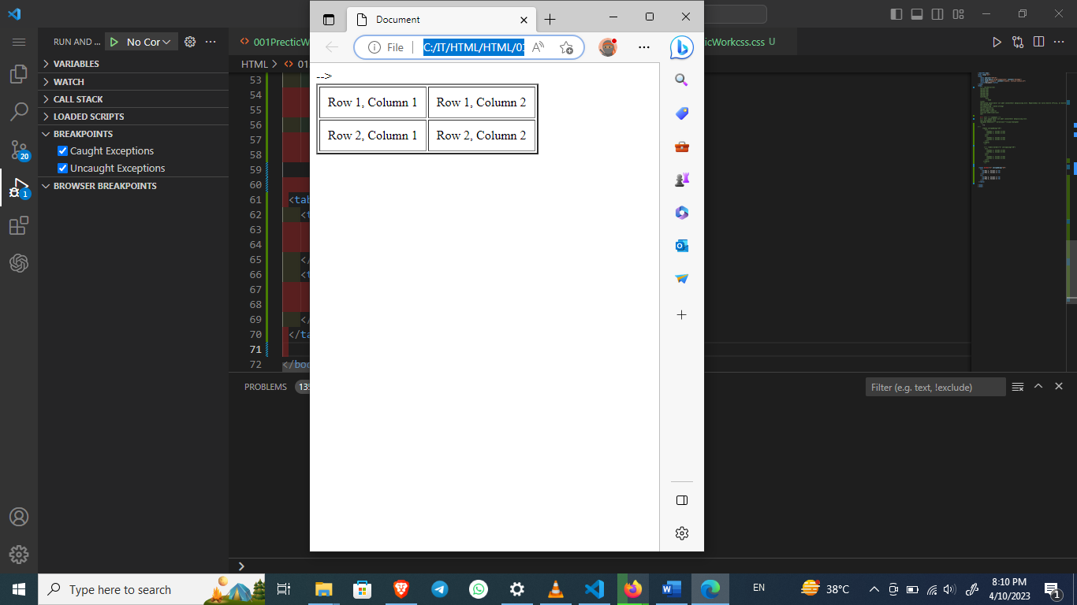

Cell spacing refers to the space between the borders of adjacent cells in a table. This attribute is used to add space between cells, and it is defined using the "cellspacing" attribute in HTML. Example: Suppose we have a table with two rows and two columns, and we want to add some space between the cells. We can use the following HTML code to accomplish this:

**Example:**

<table border="2" cellspacing="10">

<tr>

<td>Row 1, Column 1</td>

<td>Row 1, Column 2</td>

</tr>

<tr>

<td>Row 2, Column 1</td>

<td>Row 2, Column 2</td>

</tr>

</table>

**Output:-**

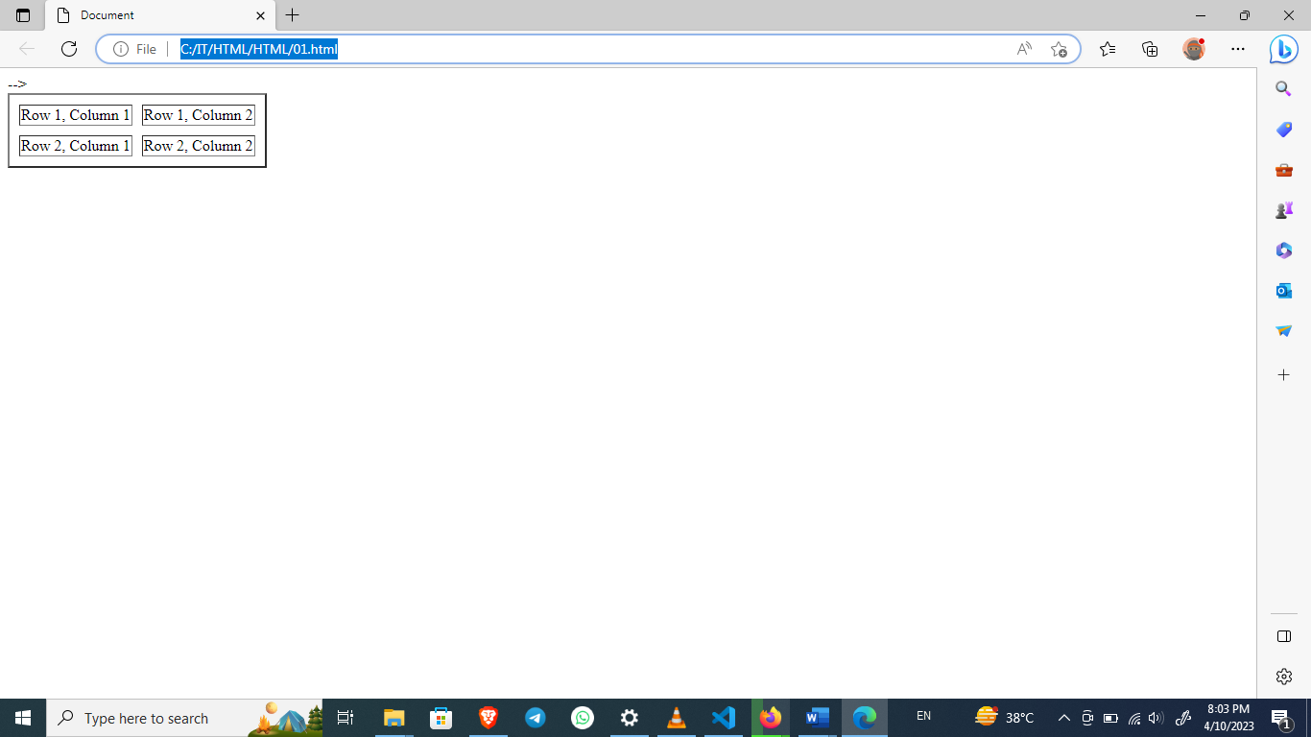

this example, we have set the cellspacing attribute to 10, which means that there will be 10 pixels of space between the borders of adjacent cells

1. **How can we club two or more rows or columns into a single row or column in an HTML table?**

Ans.:- To club two or more rows or columns into a single row or column in an HTML table, we can use the rowspan and colspan attributes, respectively. The rowspan attribute specifies the number of rows a cell should span, while the colspan attribute specifies the number of columns a cell should span. Here's an example of how to use these attributes to merge cells in an HTML table:

**Example:**

<table>

<tr>

<th rowspan="2">Name</th>

<th colspan="2">Contact</th>

</tr>

<tr>

<th>Email</th>

<th>Phone</th>

</tr>

<tr>

<td>Salman Khan</td>

<td>Bhaijan@Gmail.com</td>

<td>555-1234</td>

</tr>

<tr>

<td rowspan="2">Kajal Agrwal</td>

<td>Kajal.Agrval@Gmail.com.com</td>

<td rowspan="2">555-5678</td>

</tr>

<tr>

<td>Other Email</td>

</tr>

</table>

Output:-

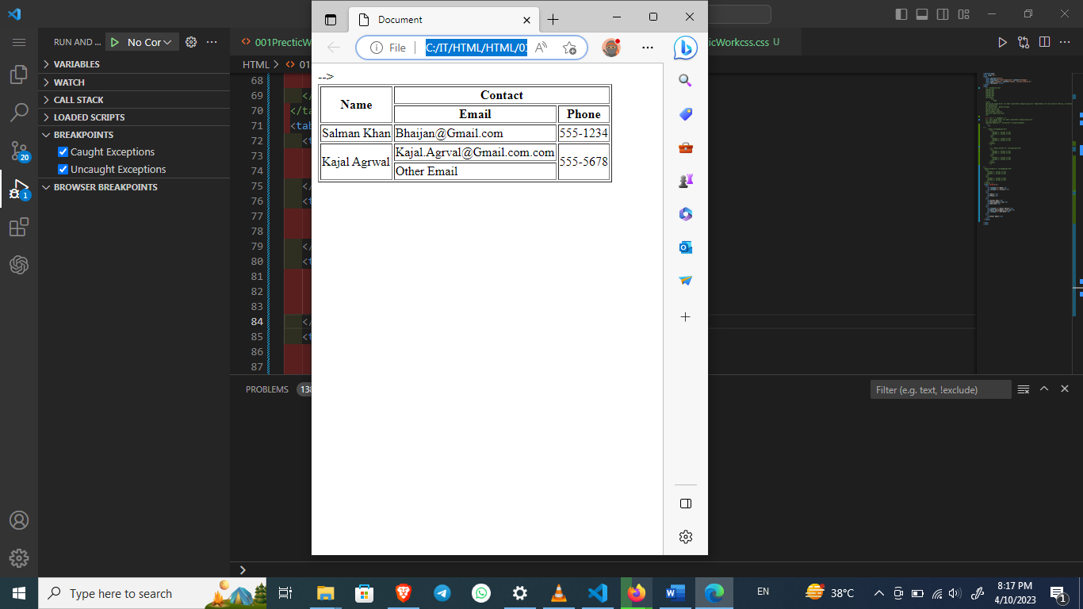

In this example, the first row has a cell with rowspan="2", which means it will span two rows. The second row has two cells with colspan="2", which means each cell will span two columns. The fourth row has a cell with rowspan="2" and a cell with colspan="1", which means the cell with rowspan="2" will span two rows, and the cell with colspan="1" will span one column. This will result in a table that looks like this:

1. **What is the difference between a block-level element and an inline element?**

To create a hyperlink in HTML, you can use the anchor tag <a> followed by the URL you want to link to. Here's an example:

**Example:**

<a href="https://www.abcWeb.com">Click here to visit AbcWeb.com</a>

he text "Click here to visit Example.com" is the visible hyperlink text, and "https://www.abcWeb.com" is the URL that the hyperlink points to. When a user clicks on this link, they will be taken to the specified URL. You can also link to other pages within your own website by using relative URLs instead of absolute URLs. For example:

**Example:**

<a href="about.html">About Us</a>

"about.html" is the relative URL of the page you want to link to. When a user clicks on this link, they will be taken to the "about.html" page within your own website. You can also add additional attributes to your anchor tag, such as target="_blank" to open the link in a new tab or window, or title="description" to add a tooltip when the user hovers over the link. Here's an example:

**Example:**

<a href="https://www.abcWeb.com" target="_blank" title="Visit abcWeb.com">Click here to visit abcWeb.com</a>

In the above code, the target="_blank" attribute will open the link in a new tab or window, and the title="Visit abcWeb.com" attribute will display a tooltip when the user hovers over the link.

1. **How to create a Hyperlink in HTML?**

To create a hyperlink in HTML, you can use the anchor tag (<a>). Here is an example:

**Example:**

<a href="https://www.abcWeb.com">Link Text</a>

In the example above, "https://www.abcWeb.com" is the URL that the hyperlink points to, and "Link Text" is the text that will be displayed on the page. When a user clicks on the "Link Text," they will be taken to the URL specified in the href attribute. You can also create a hyperlink to a section on the same page by using the id attribute. For example:

**Example:**

<a href="#section1">Link to Section 1</a>

<!-- ... other HTML ... -->

<h2 id="section1">Section 1</h2>

In this example, the href attribute is set to "#section1," which is the ID of the section you want to link to. When a user clicks on the hyperlink, the page will scroll to the section with the ID "section1."

1. **What is the use of an iframe tag?**

An <iframe> tag is used in HTML to embed another HTML document within the current document. The content inside the <iframe> tag is displayed within a rectangular frame, which can be resized and scrolled within the parent document. Here is an example of how to use an <iframe> tag:

**Example:**

<!DOCTYPE html>

<html>

<head>

<title>Example Page</title>

</head>

<body>

<h1>Example Page</h1>

<p>Here is an example of using an iframe:</p>

<iframe src="https://www.google.com" width="600" height="400"></iframe>

</body>

</html>

we have included an <iframe> tag that displays the Google website within our example page. The src attribute specifies the URL of the website that we want to embed. We have also specified the width and height of the frame to be 600 pixels and 400 pixels respectively. When you open this HTML file in a web browser, you will see the Google website displayed within the <iframe> tag on our example page.

1. **What is the use of a span tag Explain with example?**

The HTML "span" tag is used to apply styles and formatting to specific parts of text within a larger block of content. It is a generic container element that does not have any semantic meaning by itself, but it can be used to group together inline elements for styling purposes. Here's an example of how to use the "span" tag in HTML:

**Example:**

<p>Here is a <span style="color: red; font-weight: bold;">span element</span> in a paragraph.</p>

Overall, the "span" tag is a useful HTML element for applying inline styles to specific parts of content within a larger block of text.

1. **How to insert a picture into a background image of a web page?**

To insert a picture into a background image of a web page, you can follow these steps: Choose the background image you want to use and save it to your computer. Open your HTML code editor and create a new HTML file. In the HTML file, create a container for the background image using the "div" tag. For example:

**Example:**

<div id="background">

</div>

Inside the container, create another "div" tag for the picture you want to insert. For example:

**Example:**

<div id="picture">

</div>

Save your HTML file and open it in a web browser to see the results.

1. **How are active links different from normal links?**

Active links are not different from normal links in terms of their underlying HTML code, but they have additional functionality associated with them. A normal link, also known as a static link, is a hyperlink that takes you to another webpage when clicked. Once you click on a normal link, it will redirect you to a new webpage. An active link, on the other hand, may have additional functionality associated with it beyond just taking you to another webpage. For example, an active link may have some sort of script or program associated with it that allows it to perform a specific action when clicked. This could include opening a pop-up window, playing a video, triggering an animation, or submitting a form, among other things. In summary, while both normal links and active links take you to another webpage, active links have additional functionality associated with them beyond just navigating to a new page.

The active link state can be styled using CSS to indicate to the user that the link has been clicked and is currently loading.

**Example:**

<a href=<https://www.abcWeb.com/> class="active">Visit abcWeb</a>

This code creates a normal link with the addition of the "active" class, which can be styled with HTML to change the appearance of the link when it is in an active state. Overall, the difference between active links and normal links is that active links are links that have been clicked but have not yet completed their intended action, while normal links are standard hyperlinks that direct the user to a specific URL when clicked.

1. **What are the different tags to separate sections of text?**

There are several tags that can be used to separate sections of text in HTML. Here are some commonly used ones with examples: <h1> to <h6> tags: These are used for headings and subheadings in a document, with <h1> being the largest and most important and <h6> being the smallest and least important. For example:

**Example:**

<h1>Welcome to my Website</h1>

<h2>About Me</h2>

<h3>Education</h3>

**Example:**

<div>

<h1>Welcome to my Website</h1>

<p>This is a paragraph of text.</p>

</div>

These are just a few of the many tags available in HTML. The choice of which tag to use depends on the content and structure of the document.

1. **What is SVG?**

SVG stands for Scalable Vector Graphics. It is a vector-based image format that is used to create high-quality graphics and images that can be scaled up or down without losing their quality. Here is an example of an SVG code:

**Example:**

<svg width="100" height="100">

<circle cx="50" cy="50" r="40" stroke="black" stroke-width="3" fill="red" />

</svg>

**Output:-**

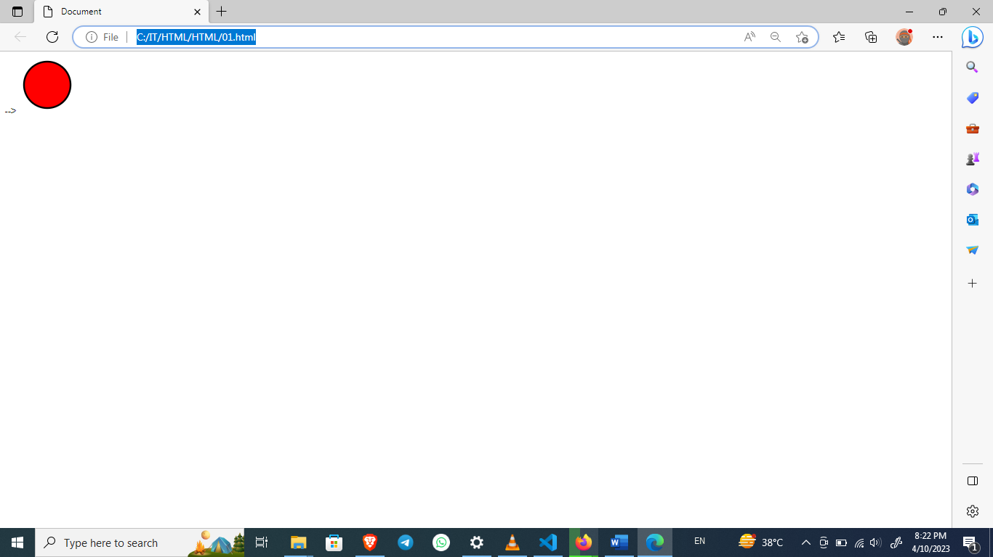

This code creates a red circle with a black stroke. The cx and cy attributes specify the center of the circle, and the r attribute specifies the radius. The stroke and stroke-width attributes control the color and width of the circle's outline, and the fill attribute specifies the color of the circle's interior. The resulting image will be a high-quality vector graphic that can be scaled up or down without losing its quality.

1. **What is difference between HTML and XHTML?**

HTML (Hypertext Markup Language) and XHTML (Extensible Hypertext Markup Language) are both markup languages used for creating web pages. However, there are some key differences between the two.

Syntax: HTML syntax is less strict than XHTML. XHTML follows the stricter XML syntax rules, which means that tags and attributes must be properly closed, nested, and written in lowercase.

Compatibility: HTML is backward compatible, meaning that older versions of HTML can still be used in modern web browsers. However, XHTML requires strict adherence to syntax rules and is not backward compatible. This means that older web pages written in HTML may not display properly in browsers that require XHTML.

Document Type Declaration (DTD): XHTML requires a specific DTD to be declared in the document to ensure that the syntax rules are followed. HTML does not require a DTD declaration. MIME Type: XHTML requires a MIME type of application/xhtml+xml to be specified in the HTTP header, while HTML does not require any specific MIME type. Here is an example of the same webpage written in both HTML and XHTML:

HTML **Example:**

<!DOCTYPE html>

<html>

<head>

<title>Example</title>

</head>

<body>

<h1>Hello World!</h1>

<p>This is an example of HTML markup.</p>

</body>

</html>

XHTML **Example:**

<?xml version="1.0" encoding="U0TF-8"?>

<!DOCTYPE html PUBLIC "-//Google//DTD XHTML 1.0 Strict//EN"

"http://www.Google.com/TR/xhtml1/DTD/xhtml1-strict.dtd">

<html xmlns="http://www.Google.com/1999/xhtml">

<head>

<title>Example</title>

</head>

<body>

<h1>Hello World!</h1>

<p>This is an example of XHTML markup.</p>

</body>

</html>

Note that in the XHTML example, all tags are closed properly and written in lowercase, a DTD declaration is included, and the MIME type is specified in the HTTP header.

1. **What are logical and physical tags in HTML?**

HTML, tags are used to mark up content and indicate to the browser how it should be displayed. There are two types of tags in HTML:

logical tags and physical tags. Logical tags are used to describe the meaning or purpose of the content, and are also known as semantic tags. These tags are important for search engine optimization (SEO) and accessibility purposes, as they provide additional information about the content to assistive technologies like screen readers. Here are some examples of **logical tags**: .

**Example:**

<header>: Defines a header for a document or section.

<nav>: Defines a container for navigation links.

<section>: Defines a section of content.

<footer>: Defines a footer for a document or section. Physical tags, on the other hand, are used to define the appearance or presentation of the content, and are also known as presentational tags.

**Example:**

<h1>Welcome to my website</h1>

<p>This is the first paragraph of my page.</p>

<strong> Defines strong text i.e. show the importance of the text.</strong>

**Here are some examples of physical tags:**

<b>: Bold text.

<i>: Italicized text.

<u>: Underlined text.

<strike>: Strikethrough text.

<font>: Defines the font family, size, and color of text.

It's important to note that while physical tags can change the appearance of content, they should not be used for structural purposes. Structural purposes should always be marked up with logical tags.